Note: Our redboard was missing the white battery connector, so we powered it via USB for this alb instead of the battery.

1)

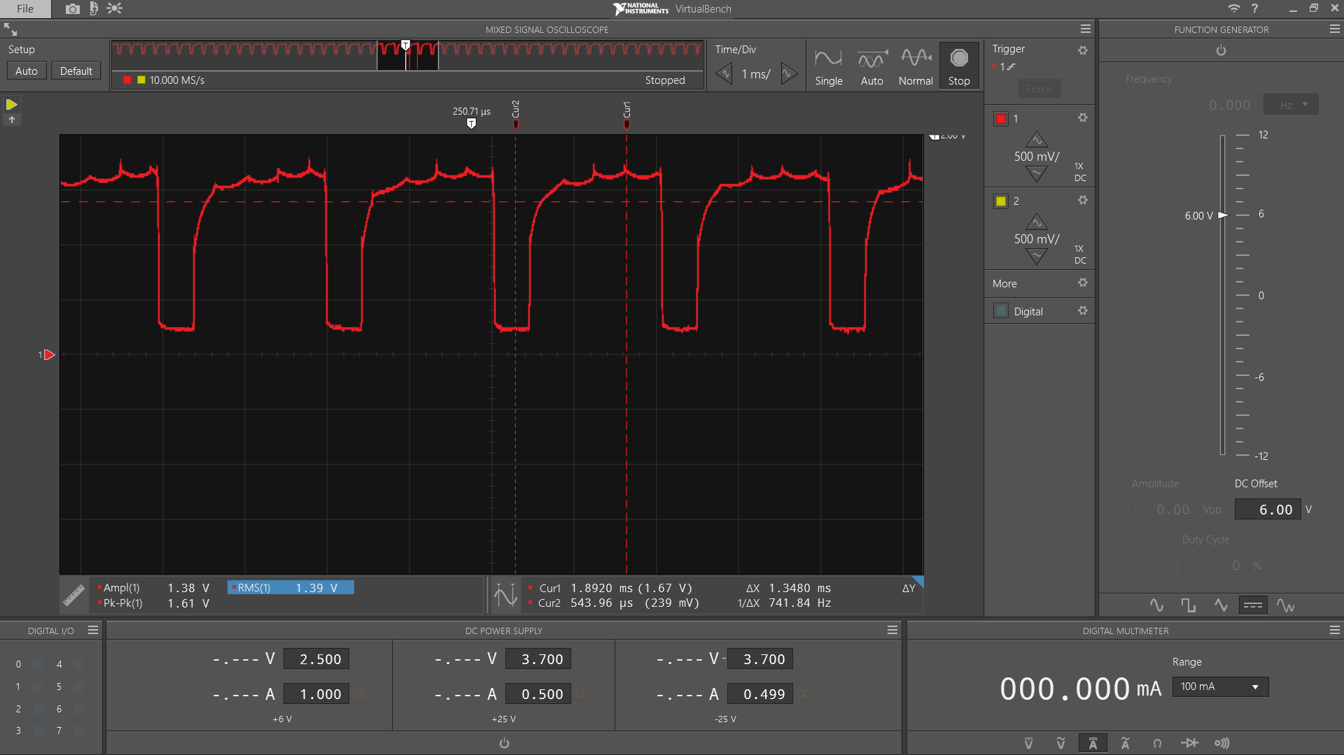

No diode, no cap - FLYBACK (239 mV – 1.67 V)

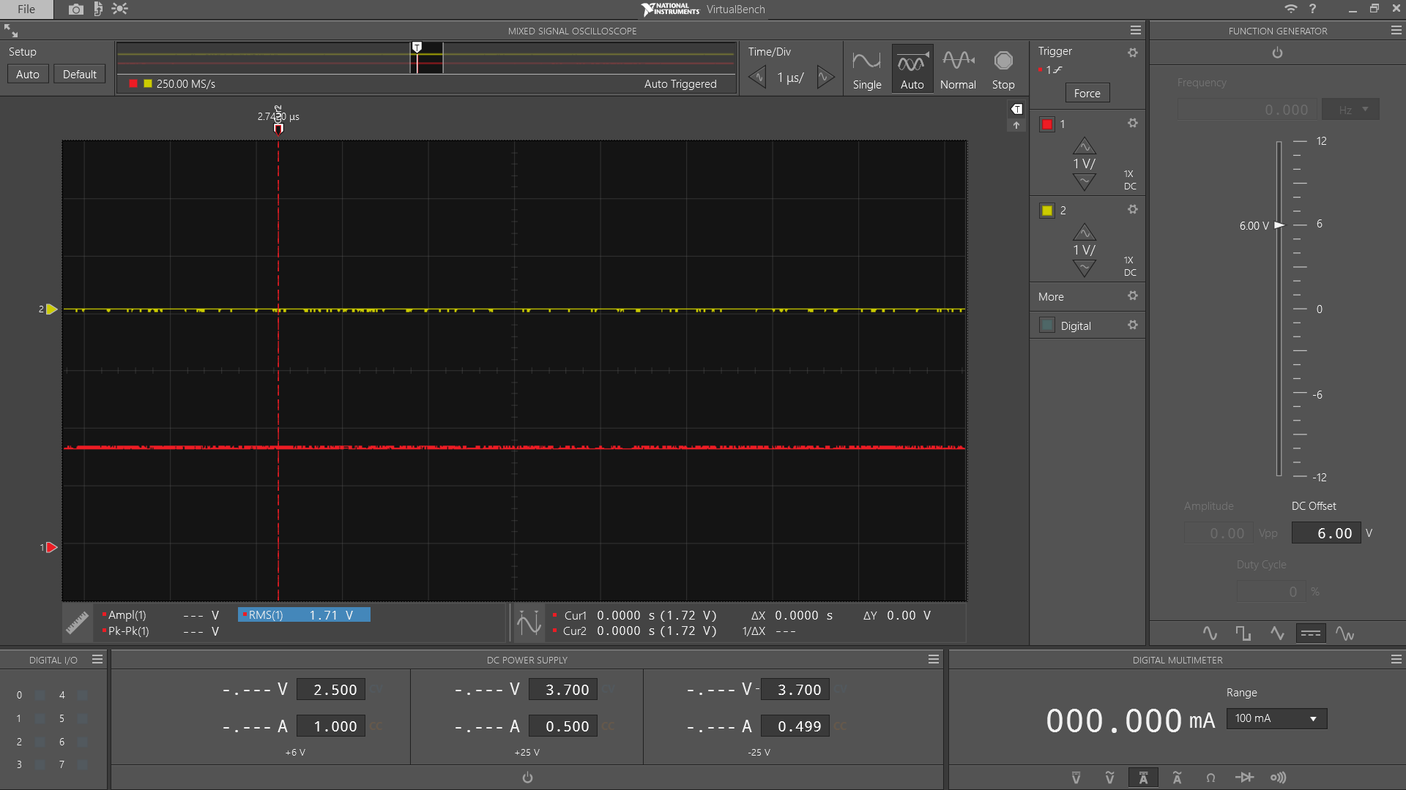

Diode, no cap -- FLYBACK (1.72 V)

2)

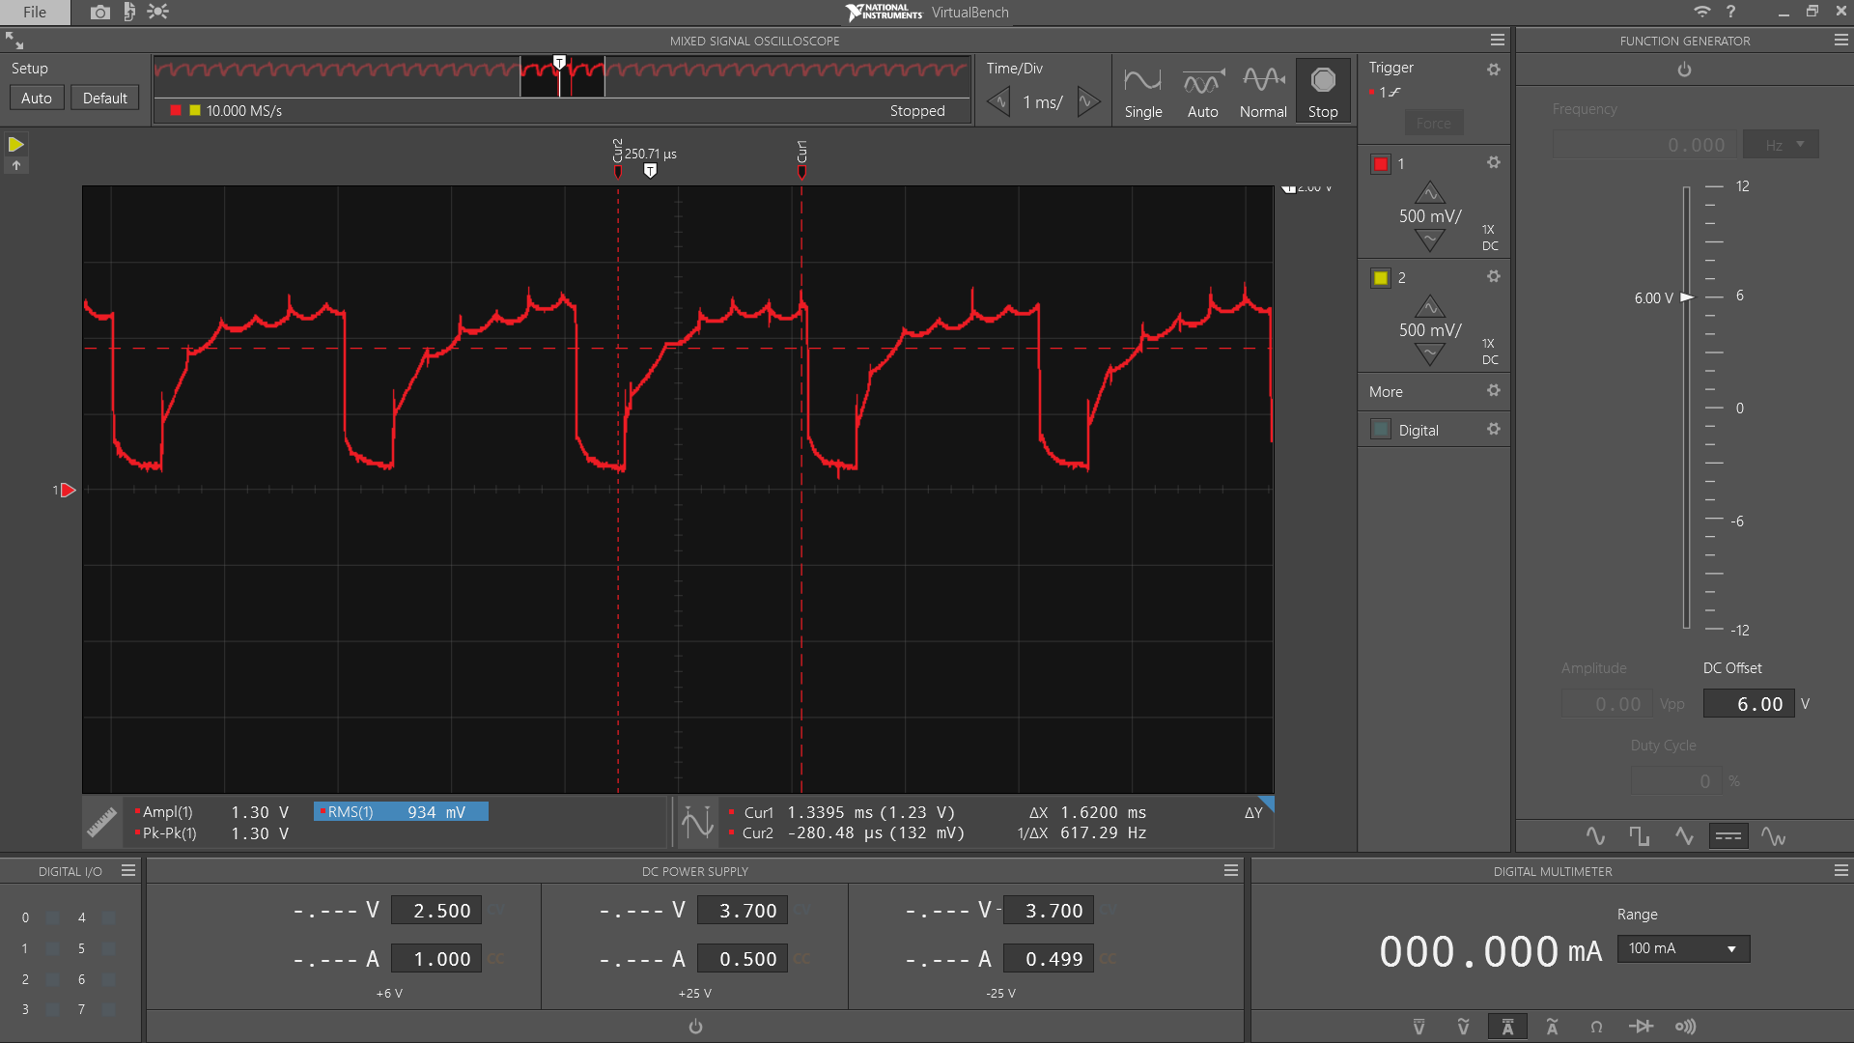

Cap, no diode – FLYBACK

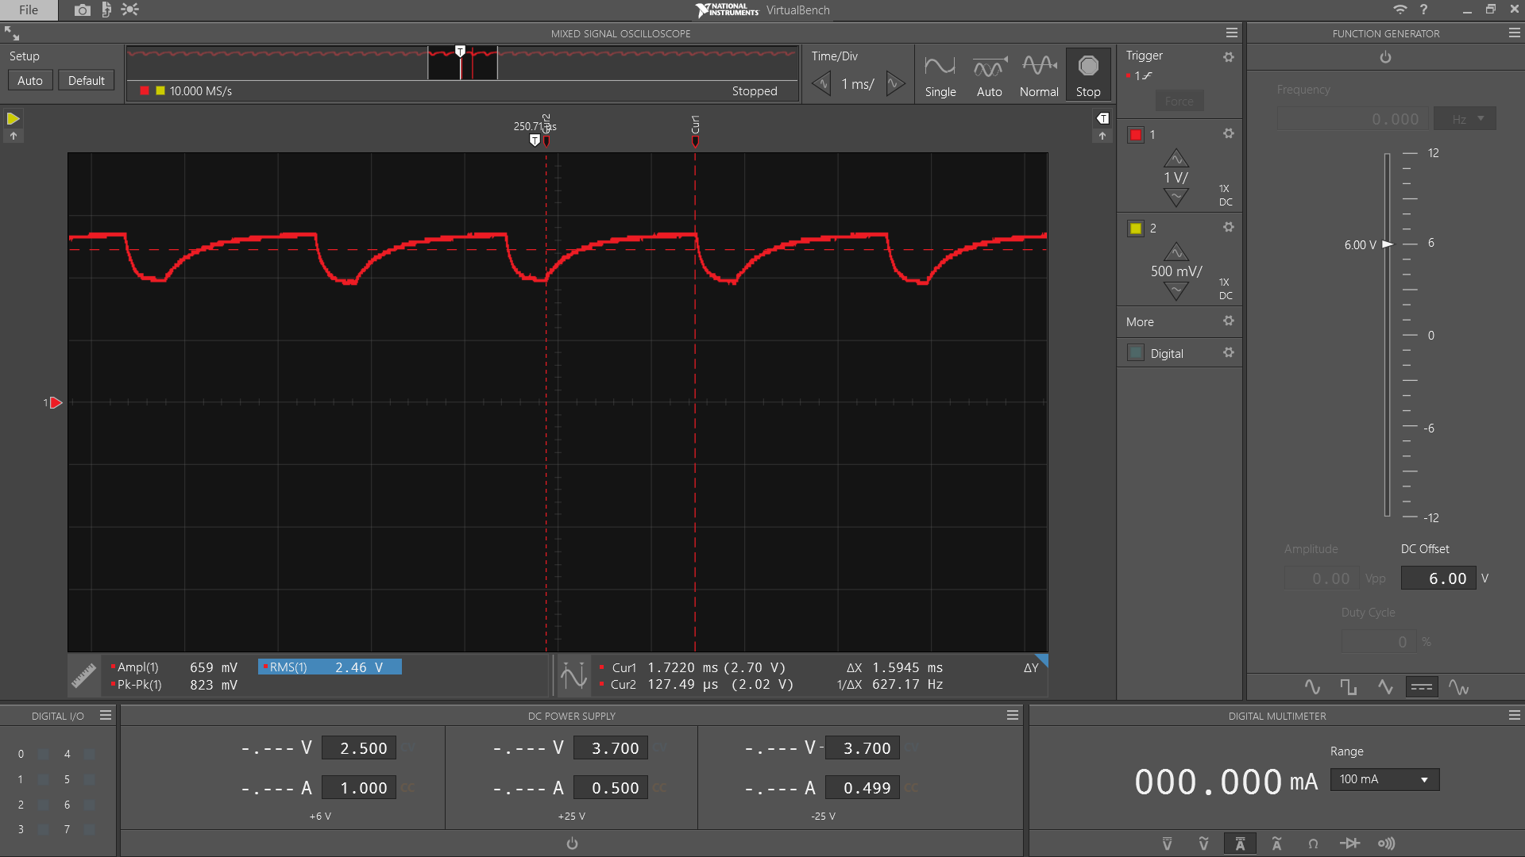

Cap, no diode – VCC (2.02 V – 2.70 V)

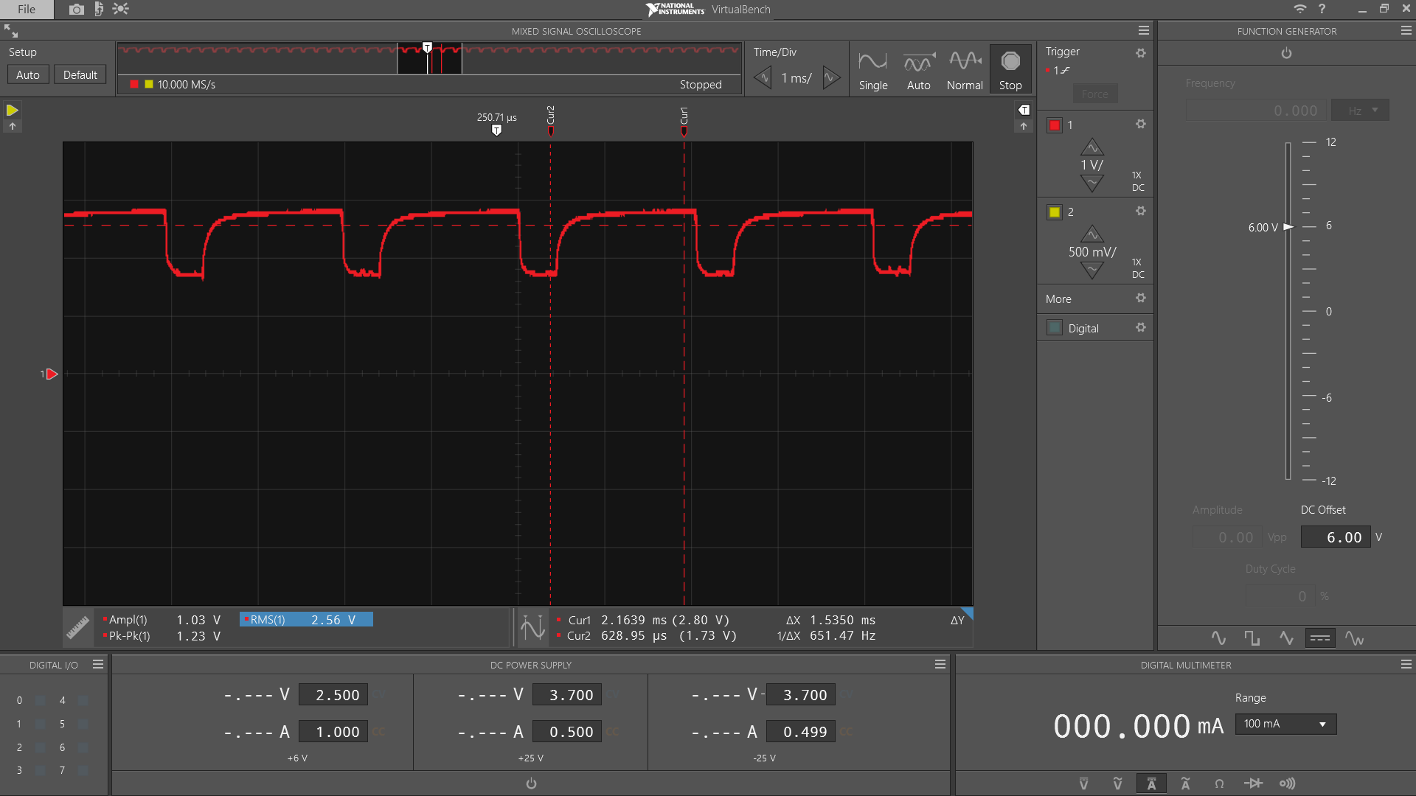

No cap, no diode – VCC (1.73 V – 2.80 V)

3)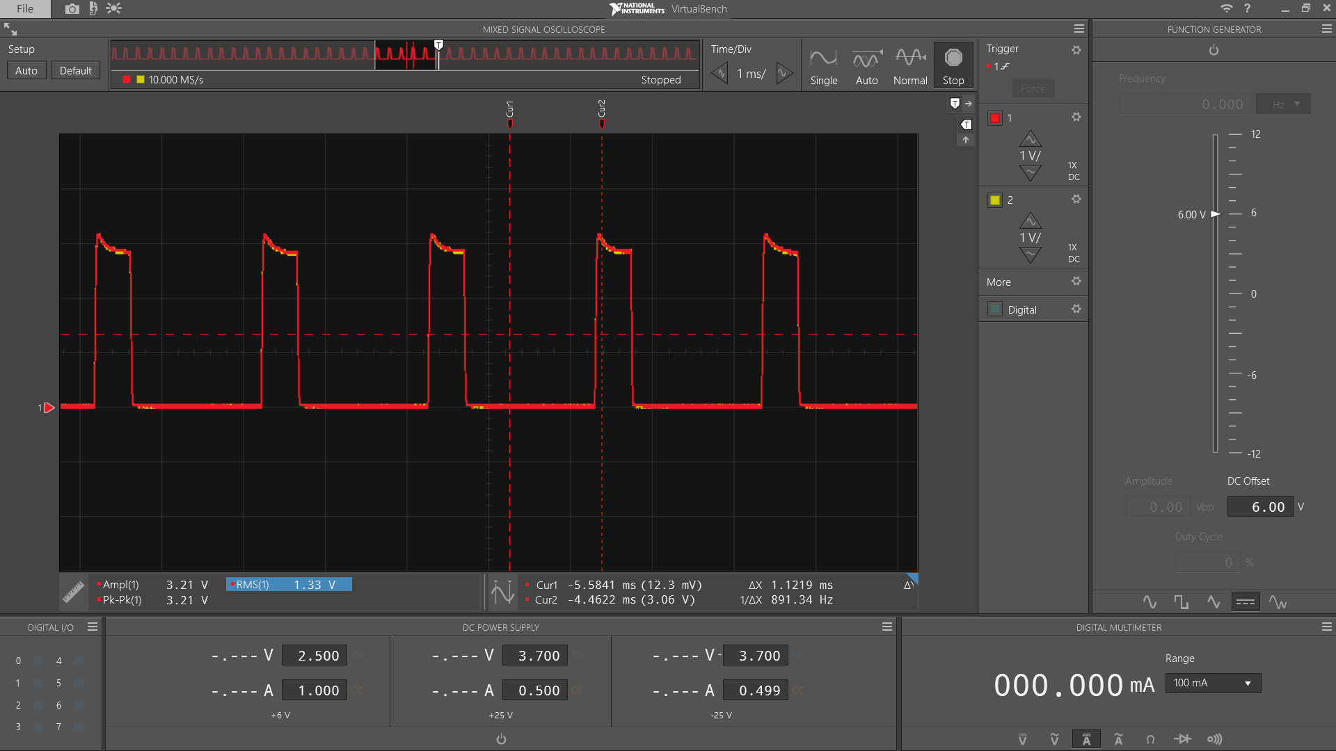

Channel 1 – PWM, Channel 2 – Filtered (~0 – ~3 V for both)

--No difference, no effect

4)

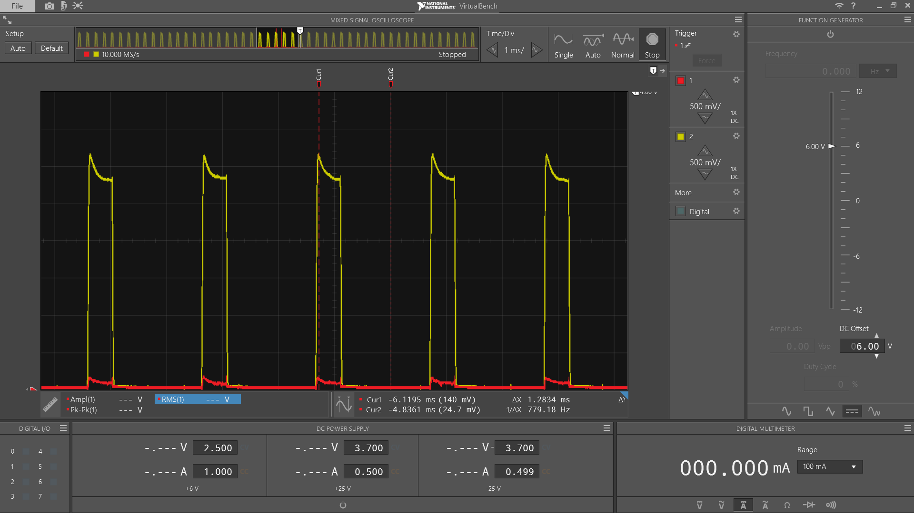

Channel 1 – Flyback (140 MV), Channel 2 – Filtered (Difference of ~3.2 V)